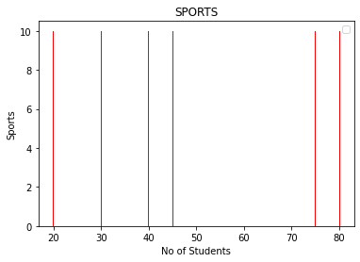
1) output

code
import numpy as np
import matplotlib.pyplot as plt

#a=np.array('cricket','football','hockey','badminten','swimming','tennis')
b=np.array((80,40,20,30,45,75))
plt.title('SPORTS')
plt.xlabel('No of Students')
plt.ylabel('Sports')
plt.bar(b,color='red',width=.2,height=10)
plt.show()

2)
a=input("enter a postive number")
b=a.split(a[:1])
print(b)
c=a.split(a[1:])
print(c)
d=b[1]
e=c[0]

f=d+e
print(f)

output

